♠ Peninsula Bridge Club ♥
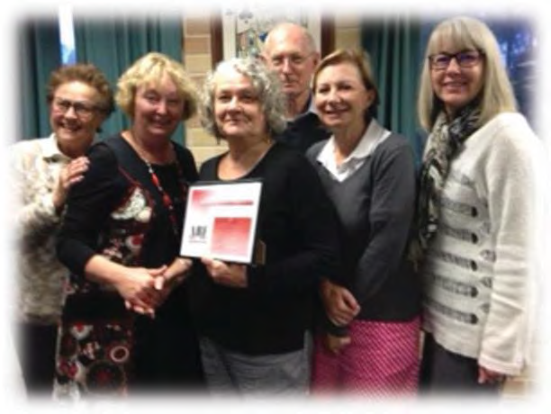
Cath Whiddon (Director of Bridge Education at Peninsula Bridge Club) was the first ABF Accredited Teacher in Australia (2014). She was joined by Susan Falkingham and Vickie Busteed in 2017. Other members of the bridge education team photographed here include Supervisers: Jen Ardill, Terry Rothwell and Jo Jarvis.
Bridge Education at Peninsula Bridge Club
Late in 2010, Colin Chase (then President of Peninsula Bridge Club) approached Cath Whiddon, a member and keen player of the Club who was reducing her professional working life and increasing her involvement in bridge. Colin was concerned that table numbers were trending downwards and that the Club’s membership was also declining with very few new members joining. He thought a beginner’s bridge course might bring in some new members and he asked Cath Whiddon to look into it.
Cath started with a group of 10 who all completed the course and expressed a desire to continue – so a supervised practise play session was formed.
In 2011, more day beginner courses were taught and evening classes were also offered for workers. A monthly conventions workshop was started for the developing beginners and improvers. A mentor program was also implemented and the club ran competitions where a new player was matched with an experienced player in a regular duplicate session to show them the competitive side of the game – but with a delicious afternoon tea and wine & cheese supper to emphasise the social side too.
In 2012 a bridge education team was needed to cater for the growing number of new players and members and more supervised sessions were offered: Jo Jarvis (Tuesday) and Terry Rothwell (Friday), Susan Falkingham (evenings). Vickie Busteed & Jen Ardill started taking the beginners and Cath concentrated on developing the improvers with a monthly lesson using materials provided by ABF teaching coordinator, Joan Butts.
By 2013, the Club’s table numbers were increasing and we had over 100 new members. The Bridge Education sub-committee was formed and supported by the Club. It developed Teams of Three and Harlequin Teams to introduce the new players to the fun of teams. The Club also offered separate supervised sessions at its Charity Day, Melbourne Cup & Christmas Party events, which was welcomed by the new, developing members.
In 2014, the Bridge Education Program at Peninsula was well-established and classes overflowed with new members thanks to word of mouth recommendations as to the professional, friendly teachers and supervisors; the lovely location and generous parking; the clean facilities and yummy food. Cath Whiddon became the first teacher in Australia to receive ABF accreditation as a Star Teacher and her first students started competing in outside congresses – with great success and enjoyment.
In 2015, the Club was recognised as a professional teaching club. Numbers continued to grow with 50+ students at improver/refresher lessons and 30+ players practising play. Developing players started competing in nationwide events and venturing to Canberra and the Gold Coast to play more competitively with their new friends.
In 2016, the Club celebrated its 50th birthday and acknowledged the benefits of bridge education to the Club (over 200 new members), the local bridge community and the wider bridge world. Thanks was given to: the foresight of past Presidents; the positive support from the Club and its members; the generous encouragement from the ABF national teaching coordinator; the professional dedication of Cath Whiddon and the Bridge Education team; and especially the friendliness of the club members.

